Contact: Jim Katz
(860) 538-2461
FOR IMMEDIATE RELEASE e-mail: katz-j@sbcglobal.com

BOLLÉ ADDS NEW SIGNATURE SERIES CAMOUFLAGE MODELS

OVERLAND PARK, Kansas – June 2, 2017 – One year ago, Bollé brought its first-ever line of camouflage sunglasses to market. The result of a collaboration with Michael Waddell, host of the Outdoor Channel show Bone Collector, the initial line featured two of the newest patterns from industry leader Realtree®: Xtra and MAX-5. For 2017, completely new styles, Breaker and Flash, are being introduced.
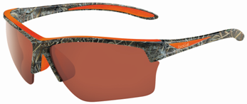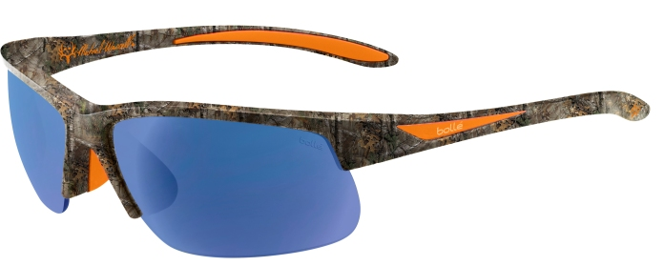
Flash – Realtree MAX-5 Breaker – Realtree Xtra
Breaker and Flash are the first sunglasses in the Michael Waddell Signature Series to have semi-rimless frame designs. In addition to a more sleek, minimalist profile; this structure allows for the convenience of interchangeable lenses. The lenses of all models in the line - whether interchangeable or fixed - are polarized and have an exterior oleophobic/hydrophobic coating, as well as an interior anti-fog treatment.

Built for use in the most demanding environments, all sunglasses in the series have frames made of lightweight, durable B88™ Nylon with Thermogrip® nose pads and temple tips for a secure, comfortable fit.

“Breaker and Flash share a long list of authentic features with the existing members of our Michael Waddell Signature Series,” noted Bill Yerby, Director of Sales and Marketing for Bollé. “The addition of these new models brings an extra measure of versatility and style to the line.”

Breaker is available now and Flash will begin shipping to retailers in March. Sunglasses in the Bollé Michael Waddell Signature Series range in price from $99.99 to $109.99. All models can be fitted with prescription lenses with Bollé’s B-Thin Active Design Rx program.
Bollé is a brand of Vista Outdoor Inc., an outdoor sports and recreation company. For more information about Serengeti, go to www.bolle.com.
About Vista Outdoor
Vista Outdoor is a leading global designer, manufacturer and marketer of consumer products in the growing outdoor sports and recreation markets. The company operates in two segments, Shooting Sports and Outdoor Products, and has a portfolio of well-recognized brands that provides consumers with a wide range of performance-driven, high-quality and innovative products for individual outdoor recreational pursuits. Vista Outdoor products are sold at leading retailers and distributors across North America and worldwide. Vista Outdoor is headquartered in Utah and has manufacturing operations and facilities in 13 U.S. States, Canada, Mexico and Puerto Rico along with international customer service, sales and sourcing operations in Asia, Australia, Canada, and Europe. For news and information, visit www.vistaoutdoor.com or follow us on Twitter @VistaOutdoorInc and Facebook at www.facebook.com/vistaoutdoor. ###

